AIT 524: Weekly Assignment 10
Tanmoy Chowdhury
George Mason University

Author Note
This task is being submitted as an assignment task 10 for the course ‘Database Management Essential’ offered in Sprig 2018. For any kind of inquiry, feel free to contact at tchowdh6@masonlive.gmu.edu.

Online Drill
The ERD from assignment 04 & 06 has been used here.
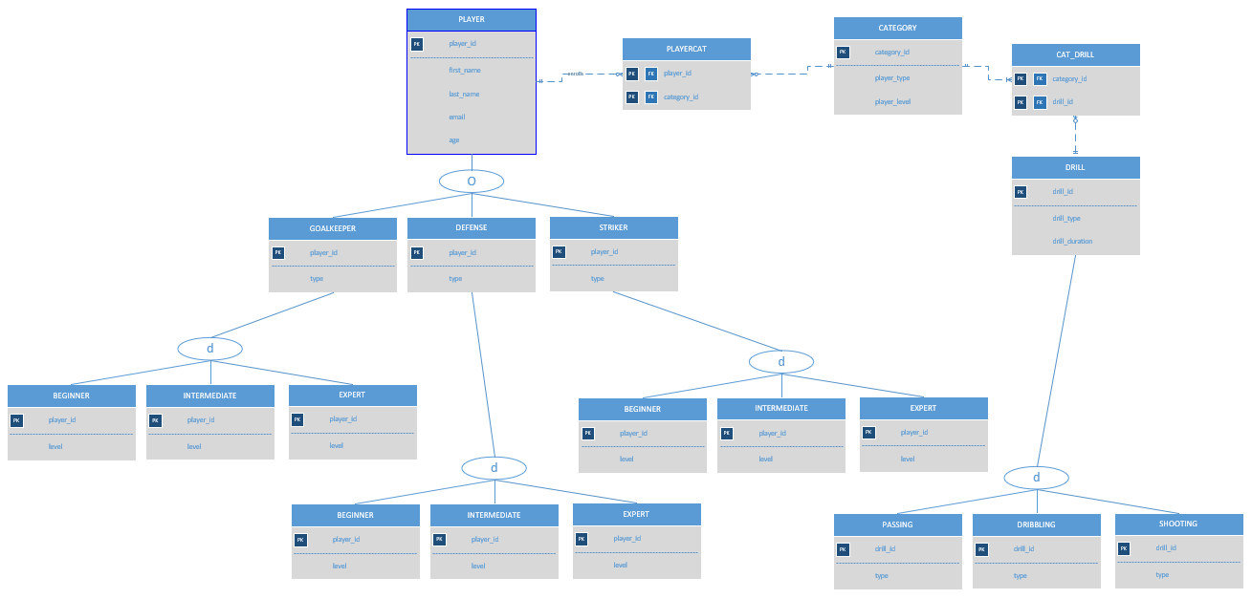
Figure 01: ERD from Assignment 04

Modification:
- I edited the entity name ‘BEGINNER’, ‘INTERMEDIATE’, ‘EXPERT’ as it seems like confusing for me when I am creating this subclass under their parent classes.
- I did not create ‘PASSING’, ‘DRIBBLING’ AND ‘SHOOTING’ entities as they inherit the same attribute from their parent class ‘DRILL’.
- I preferred to use all upper case in command and table name.

Presentation:
An sql file has also been attached in submission attempt.
Procedure & Output:

- Write a SQL code to join two tables using the WHERE statement. Explain what the query is intended to do.
Explanation: It will show the player’s first name, age and also their category. Though category is not included in PLAYER table but it will fetched that from PLAYERCAT table.
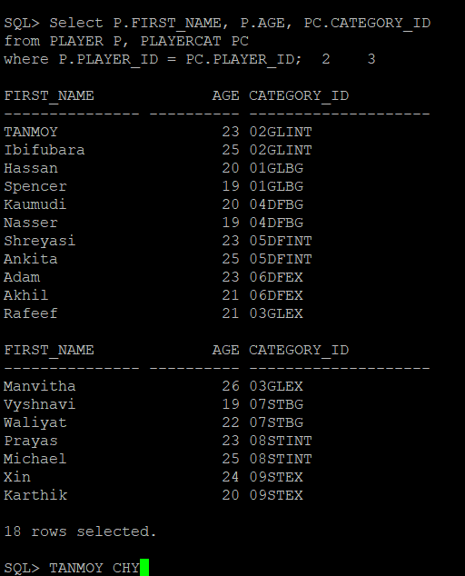

- Repeat problem 1 using the JOIN … USING keywords.
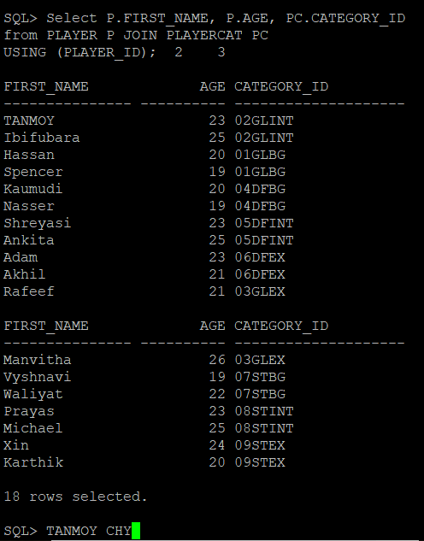
- Repeat problem 1 using the JOIN … ON keywords.
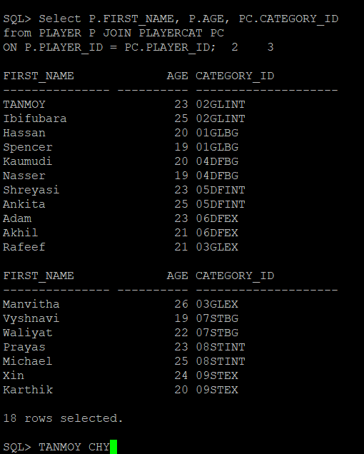
- Repeat problem 1 but add at least two conditions in the WHERE statement and use an arithmetic and a special operator. Use logical operators to combine multiple conditions. Explain what the query is intended to do.
Explanation: Those players whose first name started with ‘M’ (special operator) and half of age (arithmetic operator) is greater than 12 will be chosen and their first name, age and category will be shown.
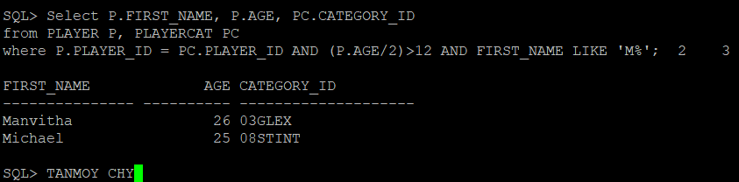
- Repeat problem 2 but add two more conditions in the WHERE statement and use an arithmetic and a special operator which are different from the ones you used in the previous query. Use logical operators to combine multiple conditions. Explain what the query is intended to do.
Explanation: Those players whose first name started with ‘X’ (special operator) and half of age (arithmetic operator) is less than 12 will be chosen and their first name, age and category will be shown.
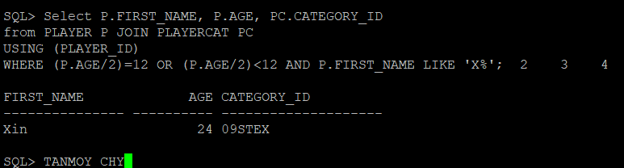

- Repeat problems 1 above to join three tables.
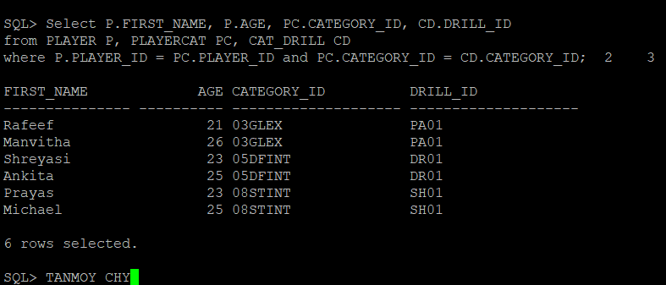
- Repeat problems 2 above to join three tables.
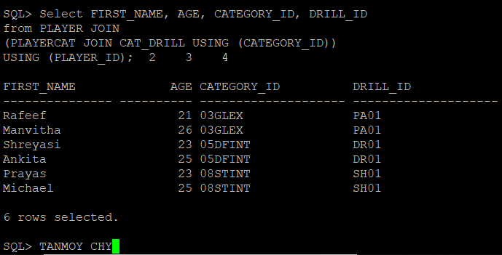

- Repeat problems 3 above to join three tables.
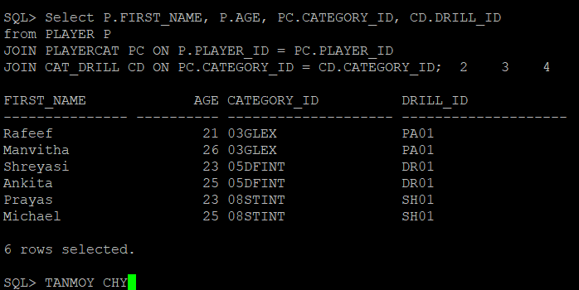
- Repeat problems 4 above to join three tables.
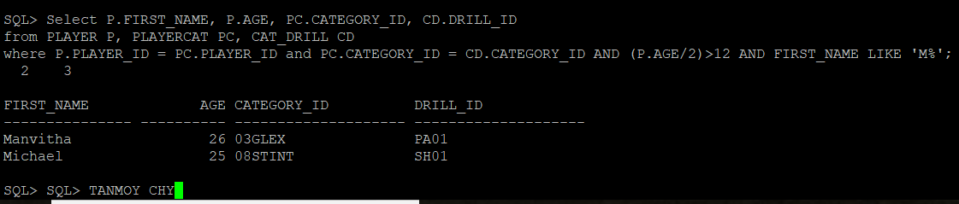
- Write a SQL query that joins four tables using any type of join and uses both an arithmetic and special operator. Explain what the query is intended to do.
Explanation: Those players whose first name started with ‘R’ (special operator) and half of age (arithmetic operator) is equal to 12 or less than 13, will be chosen and their first name, age and category, drill id, drill type will be shown.
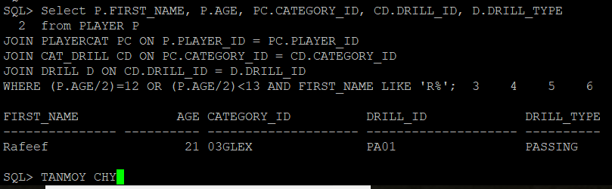

References
Casteel, J. (2016). Database system concepts and architecture in M. J. Horton, Oracle® 12c: SQL : Cengage Learning.

